Joel Atkinson

June 25,2025

Assignment 7.2

Advanced Python CSD-325

Run city_country function 3 times with two parameters:

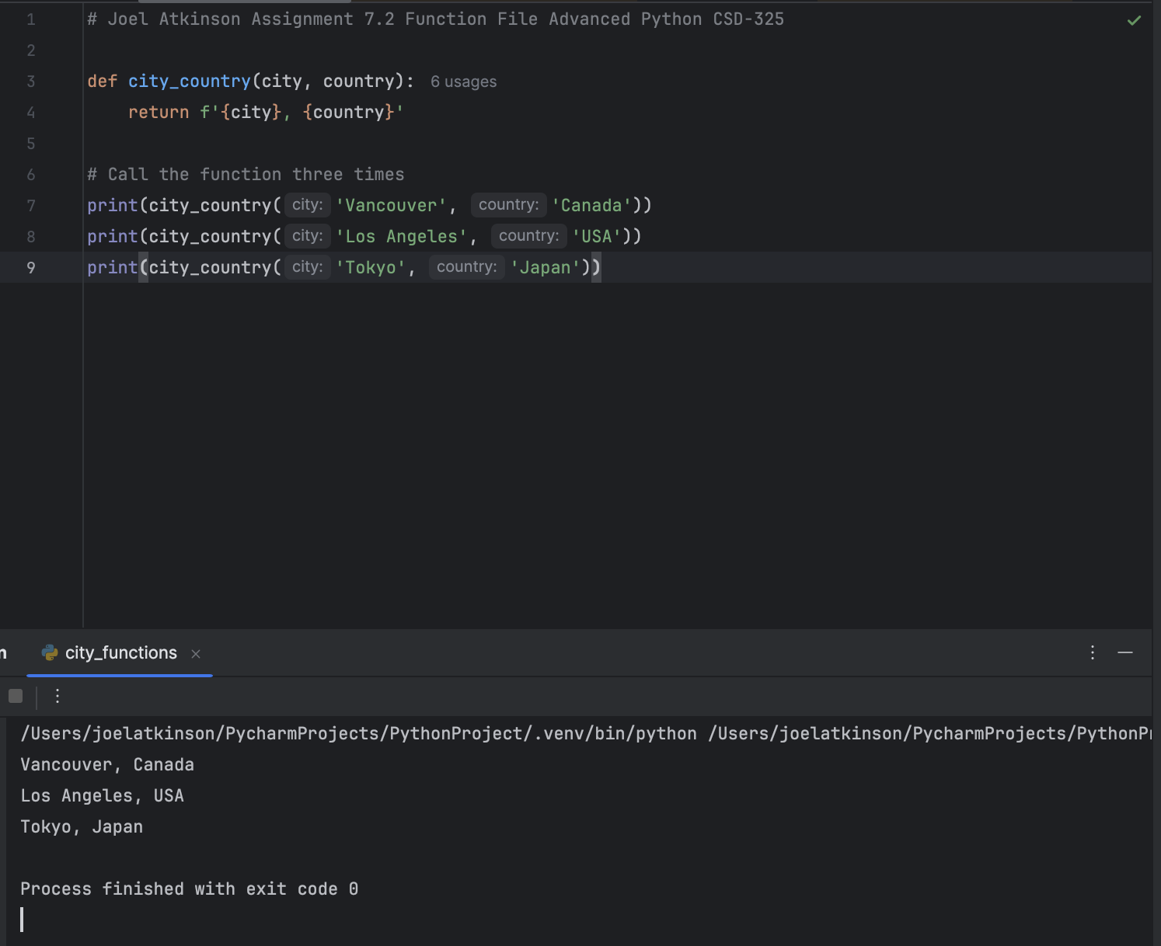

Test_cities run showing that test_city_countries passed:

Added third (population) parameter and ran city_country and had it fail:

Change (population) parameter to be optional and run test_cities again:

Added fourth parameter (language) which failed due to it being a non-default parameter following a default parameter:

Made (language) optional, ran test_cities again and test passed:

Ran city_country again and call the function 3 times, one with City, Country, one with City, Country, Population, & one with City, Country, Population, Language.

